**Chapter 09 To 11 : User Input And Conditional Statement**

1. Write a program to take “city” name as input from user. If user enters “Karachi”, welcome the user like this: “Welcome to city of lights”

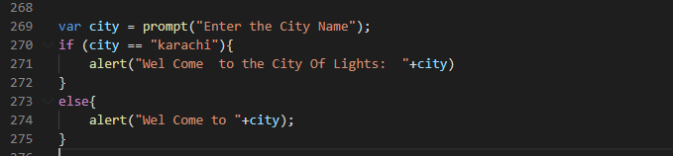

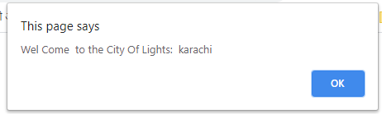

1. Write a program to take “gender” as input from user. If the user is male, give the message: Good Morning Sir. If the user is female, give the message: Good Morning Ma’am.

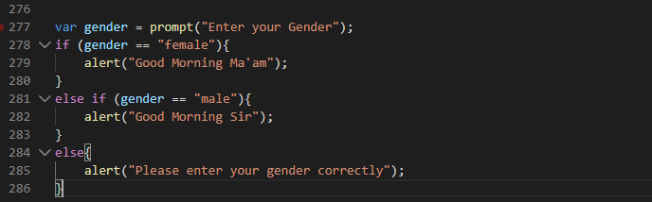

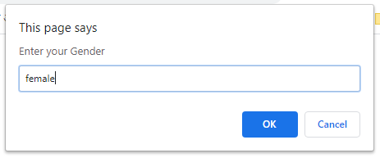

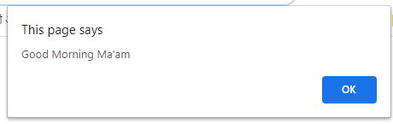

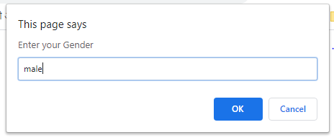

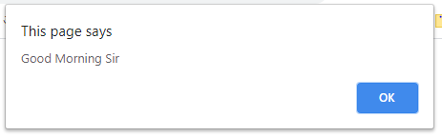

1. Write a program to take input color of road traffic signal from the user & show the message according to this table:

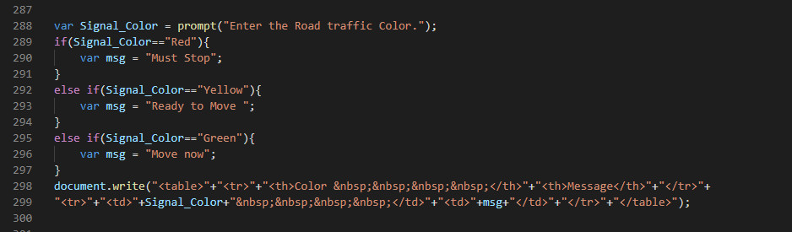

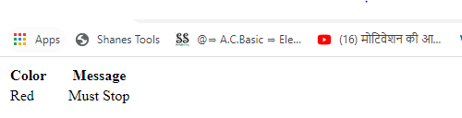

1. Write a program to take input remaining fuel in car (in litres) from user. If the current fuel is less than 0.25litres, show the message “Please refill the fuel in your car”

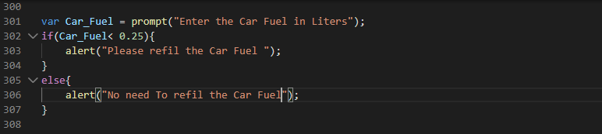

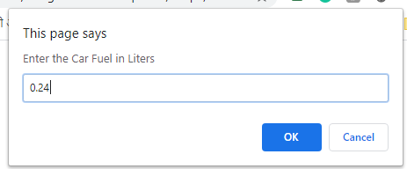

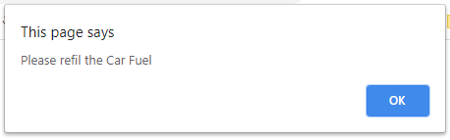

1. Run this script, & check whether alert message would be displayed or not. Record the outputs.

a)

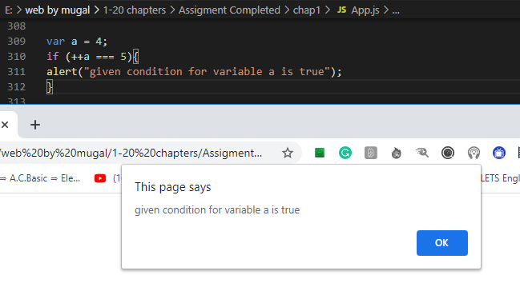

b)

c)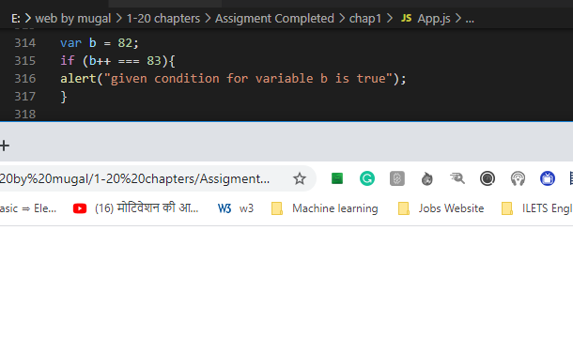

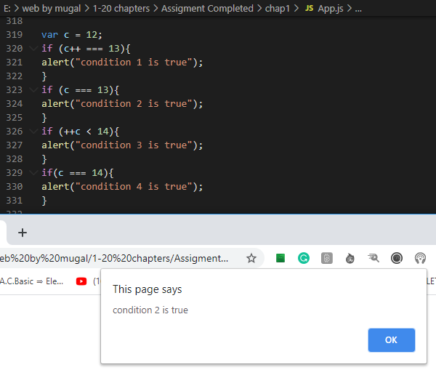

d)

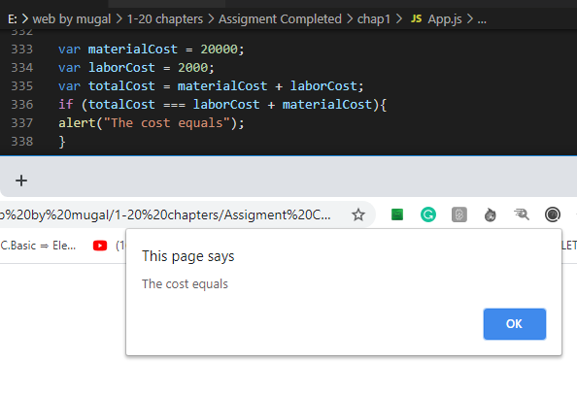

e)

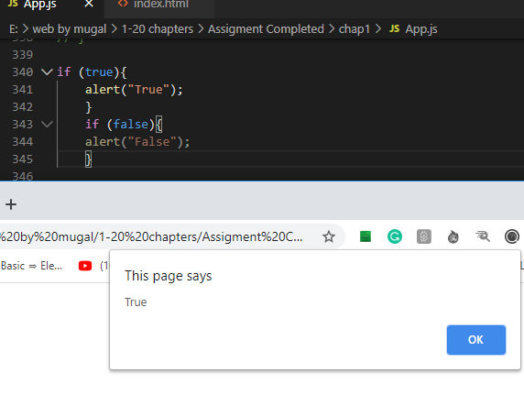

1. Write a program to take input the marks obtained in three subjects & total marks. Compute & show the resulting percentage on your page. Take percentage & compute grade as per following table:

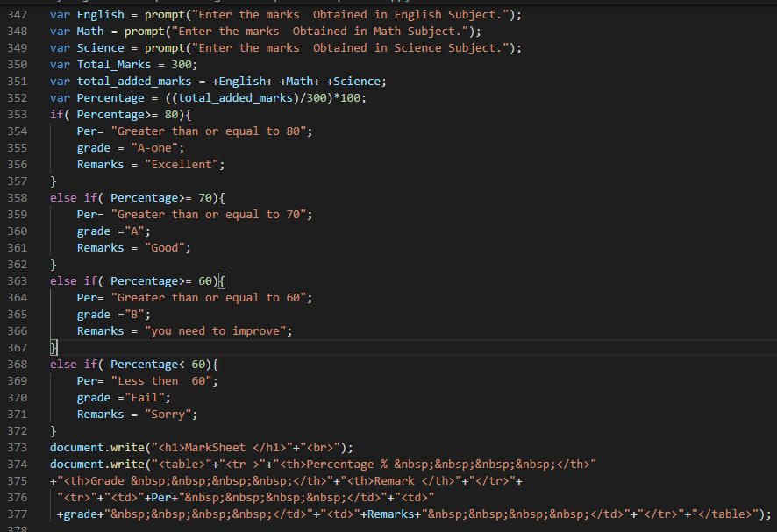

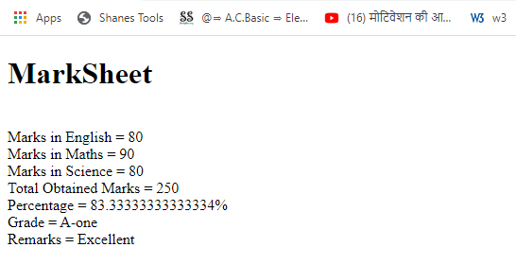

1. Guess game: Store a secret number (ranging from 1 to 10) in a variable. Prompt user to guess the secret number.

a. If user guesses the same number, show “Bingo! Correct answer”.

b. If the guessed number +1 is the secret number, show “Close enough to the correct answer”.

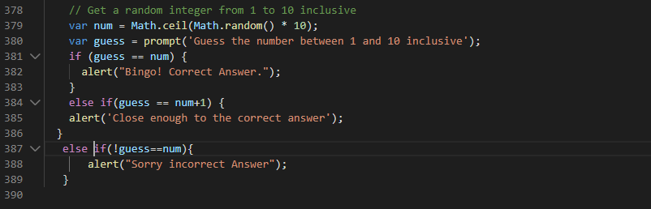

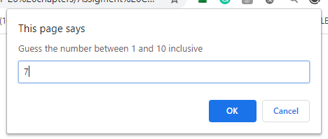

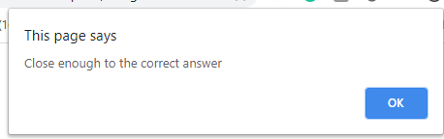

1. Write a program to check whether the given number is divisible by 3. Show the message to the user if the number is divisible by 3.

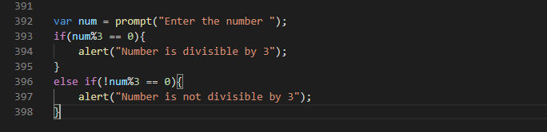

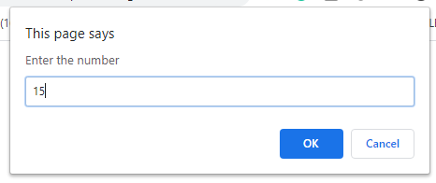

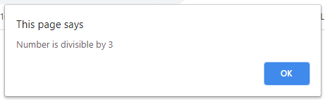

1. Write a program that checks whether the given input is an even number or an odd number.

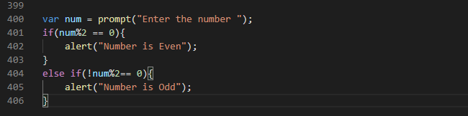

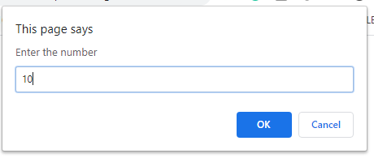

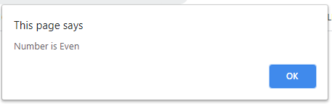

1. Write a program that takes temperature as input and shows a message based on following criteria

a. T > 40 then “It is too hot outside.”

b. T > 30 then “The Weather today is Normal.”

c. T > 20 then “Today’s Weather is cool.”

d. T > 10 then “OMG! Today’s weather is so Cool.”

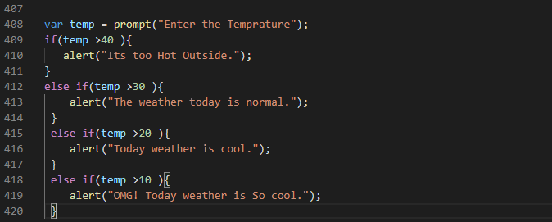

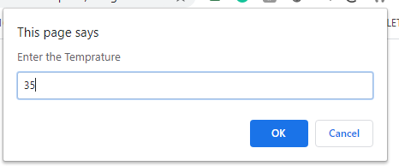

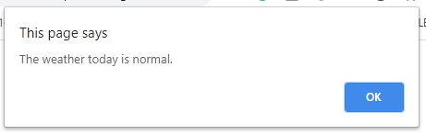

1. Write a program to create a calculator for +,-,*, / & % using if statements. Take the following input:

a. First number

b. Second number

c. Operation (+, -, *, /, %)

Compute & show the calculated result to user.

